Practical-3

**Aim:An organization has conﬁgured all the systems in such a way that each system, has a direct connection to another system. Create the topology and analyze the network in the cisco packet tracer.**

# Theory:

An organization has conﬁgured all the systems in such a way that each system, has a direct connection to another system. Create the topology and analyze the network in the cisco packet tracer.

## MESH TOPOLOGY:

**A mesh topology is a type of computer network in which each node (computer or other device) is connected to every other node in the network. This type of network is often used in large organisations or companies because it can handle a large amount of data traffic and can be easily expanded.**

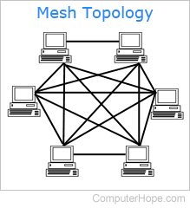

In mesh, all the computers are interconnected to every other during a network. Each computer not only sends its own signals but also relays data from other computers. The nodes are connected to every other completely via a dedicated link during which information is travel from nodes to nodes and there are N(N-1)/2 links in mesh if there are N nodes. Every node features a point-to-point connection to the opposite node. The connections within the mesh are often wired or wireless.

# Outputs:

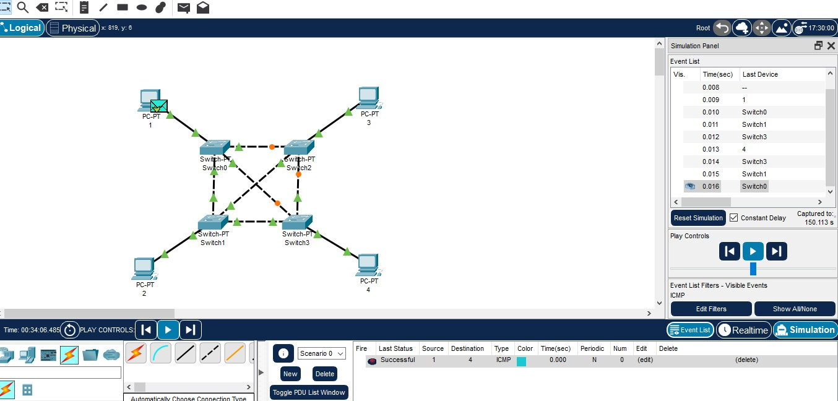

**Conclusion:** Here we learn about mesh topology.

# Question Answers:

## What is network topology? Answer:

Topology refers to the arrangement or layout of the various elements (such as computers, servers, routers, and other devices) and the connections between them. It defines how these devices are physically or logically connected to each other to facilitate the exchange of data.

## What is bus topology?

**Answer:** In bus topology, all devices share a single communication line, called a bus.

Data is transmitted along the bus, and each device on the network reads the data to determine if it is the intended recipient. Simple and cost-effective, but performance can degrade as more devices are added.

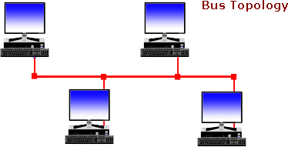

## What is star topology? Answer:

In star topology, all devices are connected to a central hub or switch. The central hub acts as a repeater and manages the flow of data between devices. Easy to install and manage, and a failure in one device typically doesn't affect others.

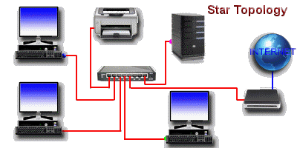

## What is tree topology? Answer:

Tree topology is a combination of bus and star topology. Devices are arranged hierarchically, with a central bus connecting different star topologies. Scalable and provides a balance between performance and cost.

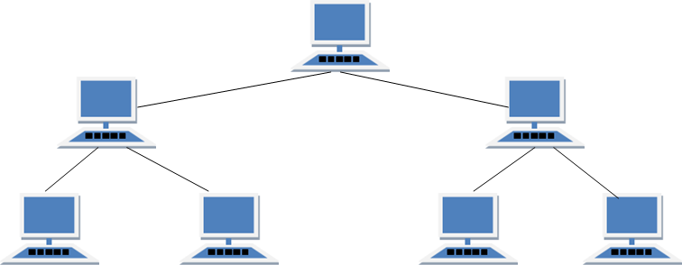

## What is Mesh topology? Answer:

In a mesh topology, every device is connected to every other device in the network. Offers high redundancy and reliability, but it can be complex and expensive to implement.

